**Tableau Project: Global ESG Data Analysis and Benchmarking**

**I. Project Goal and Stakeholder Value**

The primary objective is to create a single-source dashboard for stakeholders (investors, policymakers, and corporate strategists) to assess and benchmark countries based on their ESG performance.

**Key Analytical Questions:**

1. **Geographic Hotspots:** Which countries lead or lag in overall ESG performance?
2. **Time Trends:** How has a country's performance on key indicators (e.g., renewable energy use, internet access) changed over the last decade?
3. **Indicator Deep Dive:** What is the distribution and ranking of countries for a specific indicator (e.g., EG.ELC.RNEW.ZS for renewable electricity consumption)?

**II. Data Requirement and Preparation (Assumed Structure)**

**Note:** The provided file contains only the indicator metadata (CountryCode, SeriesCode, DESCRIPTION). The following project assumes that a companion data file exists with the actual values.

| Column | Description | Data Type Required | Tableau Preparation |
| --- | --- | --- | --- |
| **CountryCode** | Country Identifier | String | Use to link to geographic roles for mapping. |
| **SeriesCode** | ESG Indicator Code | String | Use to join the data file with the indicator **DESCRIPTION** (from the current metadata file). |
| **Year** (Assumed) | Time Period | Date/Integer | Ensure a correct Date field is created for time-series trend lines. |
| **Value** (Assumed) | Numerical Indicator Value | Decimal Number | The core measure field for aggregation and analysis. |
| **Pillar** (Calculated) | E, S, or G | String | Create a **Calculated Field** to categorize indicators into the three ESG pillars for filtering. |

**III. Dashboard Structure and Key Visualizations**

The dashboard will be designed with a primary geographic focus, supported by trend and ranking charts.

**A. Overview: Global ESG Map and Ranking**

| Visualization | Data Fields | Purpose |
| --- | --- | --- |
| **Choropleth Map** | CountryCode (Geography) + Average | **Geographic Assessment:** Shows a quick, color-coded view of global performance for a selected indicator (e.g., - Fertility Rate). |
| **Indicator Filter** | Filter on **SeriesCode** or **DESCRIPTION** | Allows the user to select *which* indicator is driving the map's coloring and the associated metrics. |
| **Top/Bottom 10 List** | Bar Chart: by | **Benchmarking:** Ranks the top and bottom 10 countries for the selected indicator. |

**B. Deep Dive: Trend and Detail**

| Visualization | Data Fields | Purpose |
| --- | --- | --- |
| **Time Series Trend** | Line Chart: (Y) vs. (X) | **Historical Analysis:** Shows the change in the indicator over time for a selected country. Crucial for assessing progress or decline. |
| **Scatter Plot** | of Indicator A vs. of Indicator B | **Correlation Analysis:** Used to examine the relationship between two different indicators (e.g., **Energy Use** vs. **Life Expectancy**), helping to identify policy success factors. |
| **Pillar/Region Filter** | Filters on **Pillar** (E/S/G) and **Region** (Calculated field) | Enables focused comparisons (e.g., comparing only **Environmental** indicators within **European** countries). |

**Dashboard**

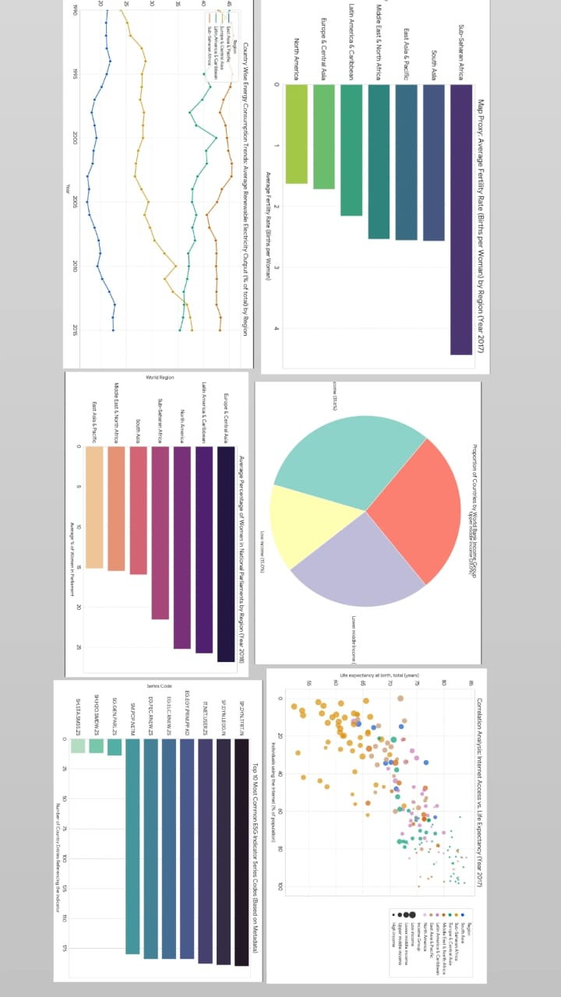

**IV. Conclusion**

The Tableau ESG Dashboard will serve as an indispensable tool for comparative analysis. By seamlessly linking geographical location, time trends, and indicator definitions, it will convert complex ESG data into a visually compelling and easily digestible narrative, directly supporting better investment and policy decisions.